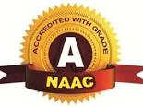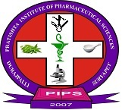 Regd. No .732/2006 Cell: 8499831950

**PRATISHTA INSTITUTE OF PHARMACEUTICAL SCIENCES**

Approved by PCI, Affiliated to SBTET and JNTUH& Recognised by Govt of Telangana

Durajpally (V), Chivvemla (M), Dist. Suryapeta. Telangana – 508 214

Website: [www.pratishtapharmacy.in](http://www.pratishtapharmacy.in), E-mail: pratishta.pharmacy@yahoo.com

Dr. Venisetty Raj Kumar Pharm., Ph.D Professor & Principal

Mobile: 7032354521

**4.3.1: institution frequently updates its IT facilities including Wi-Fi.**

Pratishta institute maintain trust on his vital area to ensure continuous and consistent availability in tune with the growing needs as well as changing technologies. The institute places lot of importance on e-learning and major plans is in hand to upgrade the band width, connectivity as well as the devices. The entire campus is optically networked between buildings and cable within the buildings for connectivity. In addition, Wi-Fi facility is provided in all the buildings. Dedicated band width (leased line) of 100 Mbps is taken from a single source. In addition each building/department of importance like examination centre, remote center for online workshops, placement cell, and library have additional dedicated band widths of 100 Mbps. Internet facility was upgraded from 64 Mbps to 100 Mbps. Two language labs were updated with infrastructure, computers and software. The library is updated with Koha software. The management has been substantially augmenting the following IT facilities since 2018: internet connectivity was increased from 64 to 100 Mbps. Intra-net connectivity is provided on the campus with 20 GBPS fiber optical cable. Installed network facilities for all computers labs installed air conditioning systems for computer labs. All the systems have been provided with backup through the uninterrupted power supply. MacAfee anti viruses software has been installed for all the systems: biometric attendance systems for PG students and faculty.

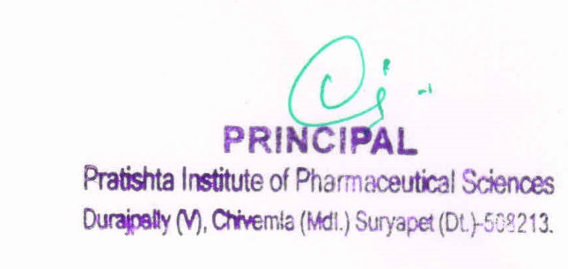

***Sponsored By Pratishta Educational Society***